Part I : Exploratory Data Analysis

Taking a Look at the Data:

Before deep diving into the data with any kind of predictive analysis, let's take a look at the Data provided by Instacart. There are total 6 preprocessed CSV files provided :

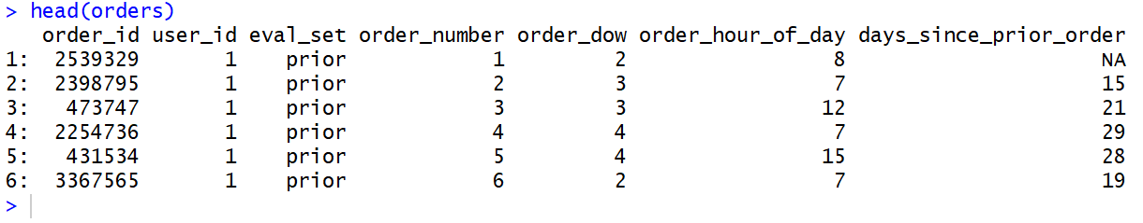
orders (3.4m rows, 206k users):
- order_id: order identifier
- user_id: customer identifier
- eval_set: which evaluation set this order belongs in (see SET described below)
- order_number: the order sequence number for this user (1 = first, n = nth)
- order_dow: the day of the week the order was placed on
- order_hour_of_day: the hour of the day the order was placed on
- days_since_prior: days since the last order, capped at 30 (with NAs for order_number = 1)

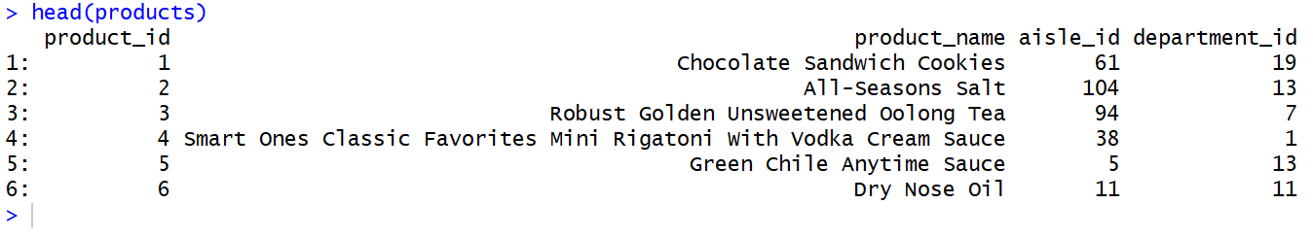
products (50k rows):
- product_id: product identifier
- product_name: name of the product
- aisle_id: foreign key
- department_id: foreign key

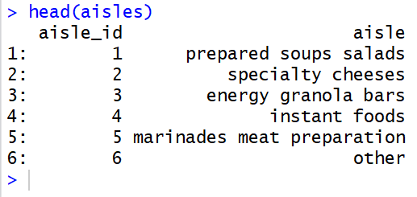

aisles (134 rows):
- aisle_id: aisle identifier
- aisle: the name of the aisle

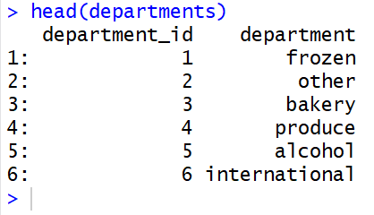

departments (21 rows):
- department_id: department identifier
- department: the name of the department

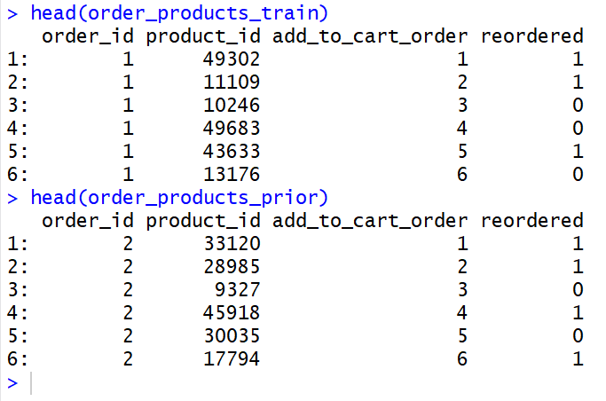

order_products__SET (30m+ rows):
- order_id: foreign key
- product_id: foreign key
- add_to_cart_order: order in which each product was added to cart
- reordered: 1 if this product has been ordered by this user in the past, 0 otherwise

where SET is one of the four following evaluation sets (eval_set in orders):
- "prior": orders prior to that users most recent order (~3.2m orders)
- "train": training data supplied to participants (~131k orders)

Data Analysis & Visualization:

1. How many Orders by the Hour of the Day?

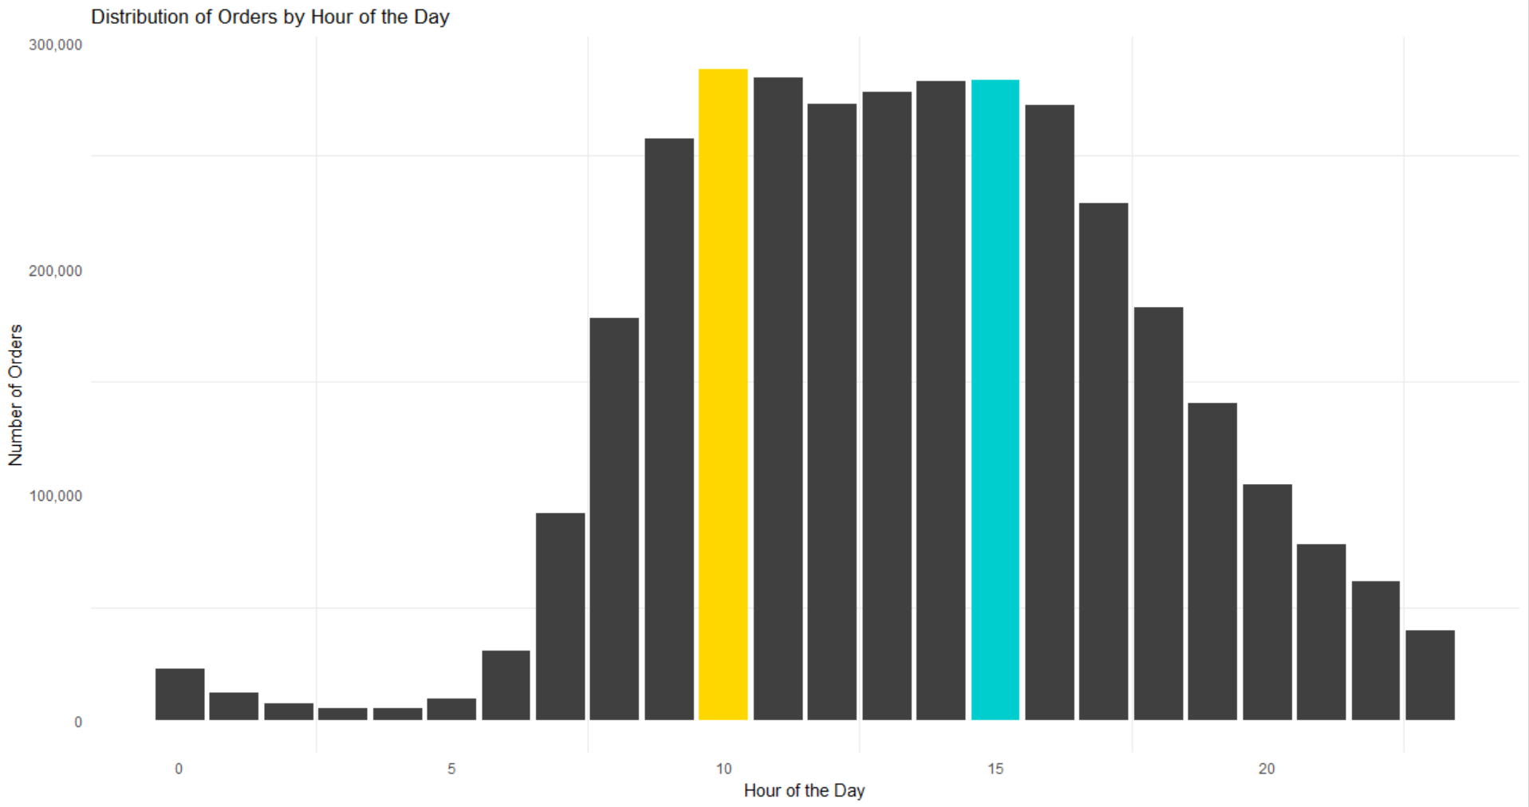
Output :

Most orders are made between the hours 09 and 16. But does this pattern exist over all days of the week?

Process :

To generate this visualization, we used the dataset Orders and we took the column named order_hour_of_the_day on the x-axis and generated a bar plot showing total Number of Orders on the y-axis with respect to the values in x-axis. To generate such visualization, the library ggplot2 is used.

Code:

ggplot(orders, aes(x = order_hour_of_day)) +
geom_bar(fill = c(rep("grey25", 10), "gold", rep("grey25", 4), "cyan3",rep("grey25", 8))) +
theme_minimal() +
theme(axis.ticks.x = element_blank(),
axis.ticks.y = element_blank(),
legend.position = "none",
panel.grid.major = element_blank()) +
labs(x = "Hour of the Day",
y = "Number of Orders",
title = "Distribution of Orders by Hour of the Day") +
scale_y_continuous(labels = comma)
2. How many Orders by Hour and Day of the Week?

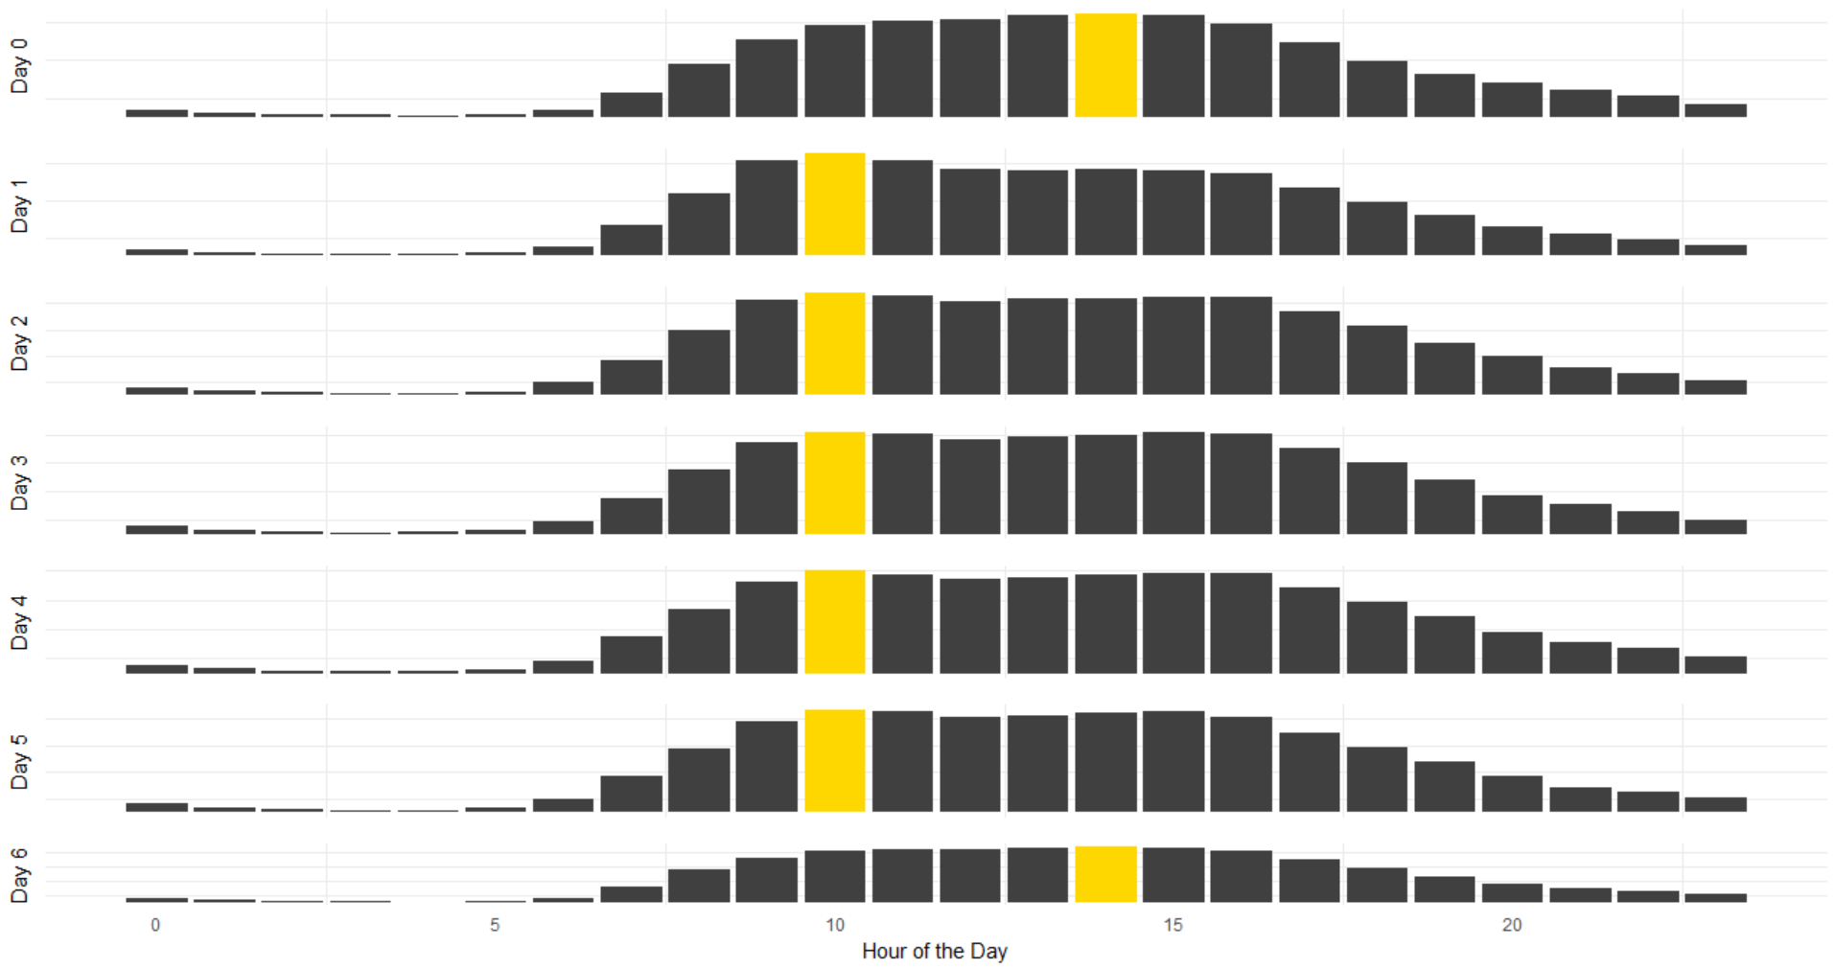
Output :

Here, the pattern we observed in (1) is no longer observed. Instead, Day 1 to Day 5 has hour 10 as the most popular hour for orders, while days 0 and 6 have hour 14 as the most popular. It suggests that Days 1 - 5 are weekdays, while Days 0 and 6 are weekends.

Process :

Here, the dataset Orders is used. The column order_hour_of_day is used in the x-axis along with total Number of Orders is on the y-axis. To generate plot for multiple days, we have created 7 variables where each stores the plot of each day. And then we joined all of them together with grid.arrange command.

Code :

p0 <- ggplot(orders[orders$order_dow == 0, ],
aes(x = order_hour_of_day)) + ...
p1 <- ...
...
p6 <- ggplot(orders[orders$order_dow == 6, ],
aes(x = order_hour_of_day)) + ...
grid.arrange(p0, p1, p2, p3, p4, p5, p6, ncol = 1)
3. How many Orders by Day of the Week?
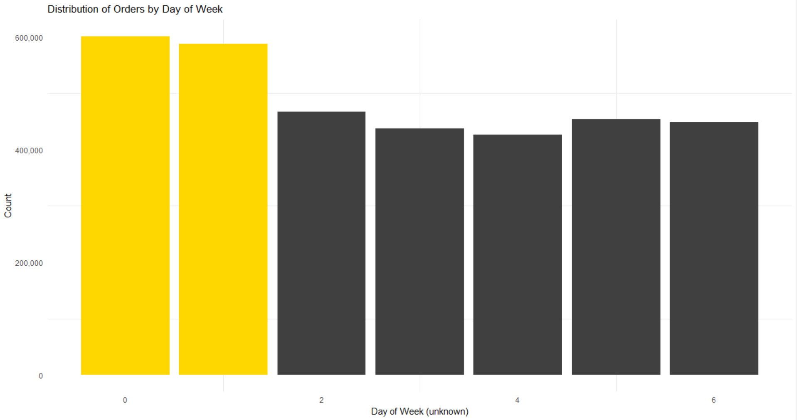

Output :

There are a lot of orders on each day of the week. However, there are significantly more orders on days 0 and 1. This may represent the weekend.

Process :

To generate this visualization, we used the dataset Orders and we took the column named order_dow on the x-axis and generated a bar plot showing total Number of Orders on the y-axis with respect to the values in x-axis.

Code:

ggplot(orders, aes(x = order_dow)) +
geom_bar(fill = c(rep("gold", 2), rep("grey25", 5))) +
theme_minimal() +
theme(axis.ticks.x = element_blank(),
axis.ticks.y = element_blank(),
legend.position = "none",
panel.grid.major = element_blank()) +
labs(x = "Day of Week (unknown)",
y = "Count",
title = "Distribution of Orders by Day of Week") +
scale_y_continuous(labels = comma)

4. How many items do People buy per Order?

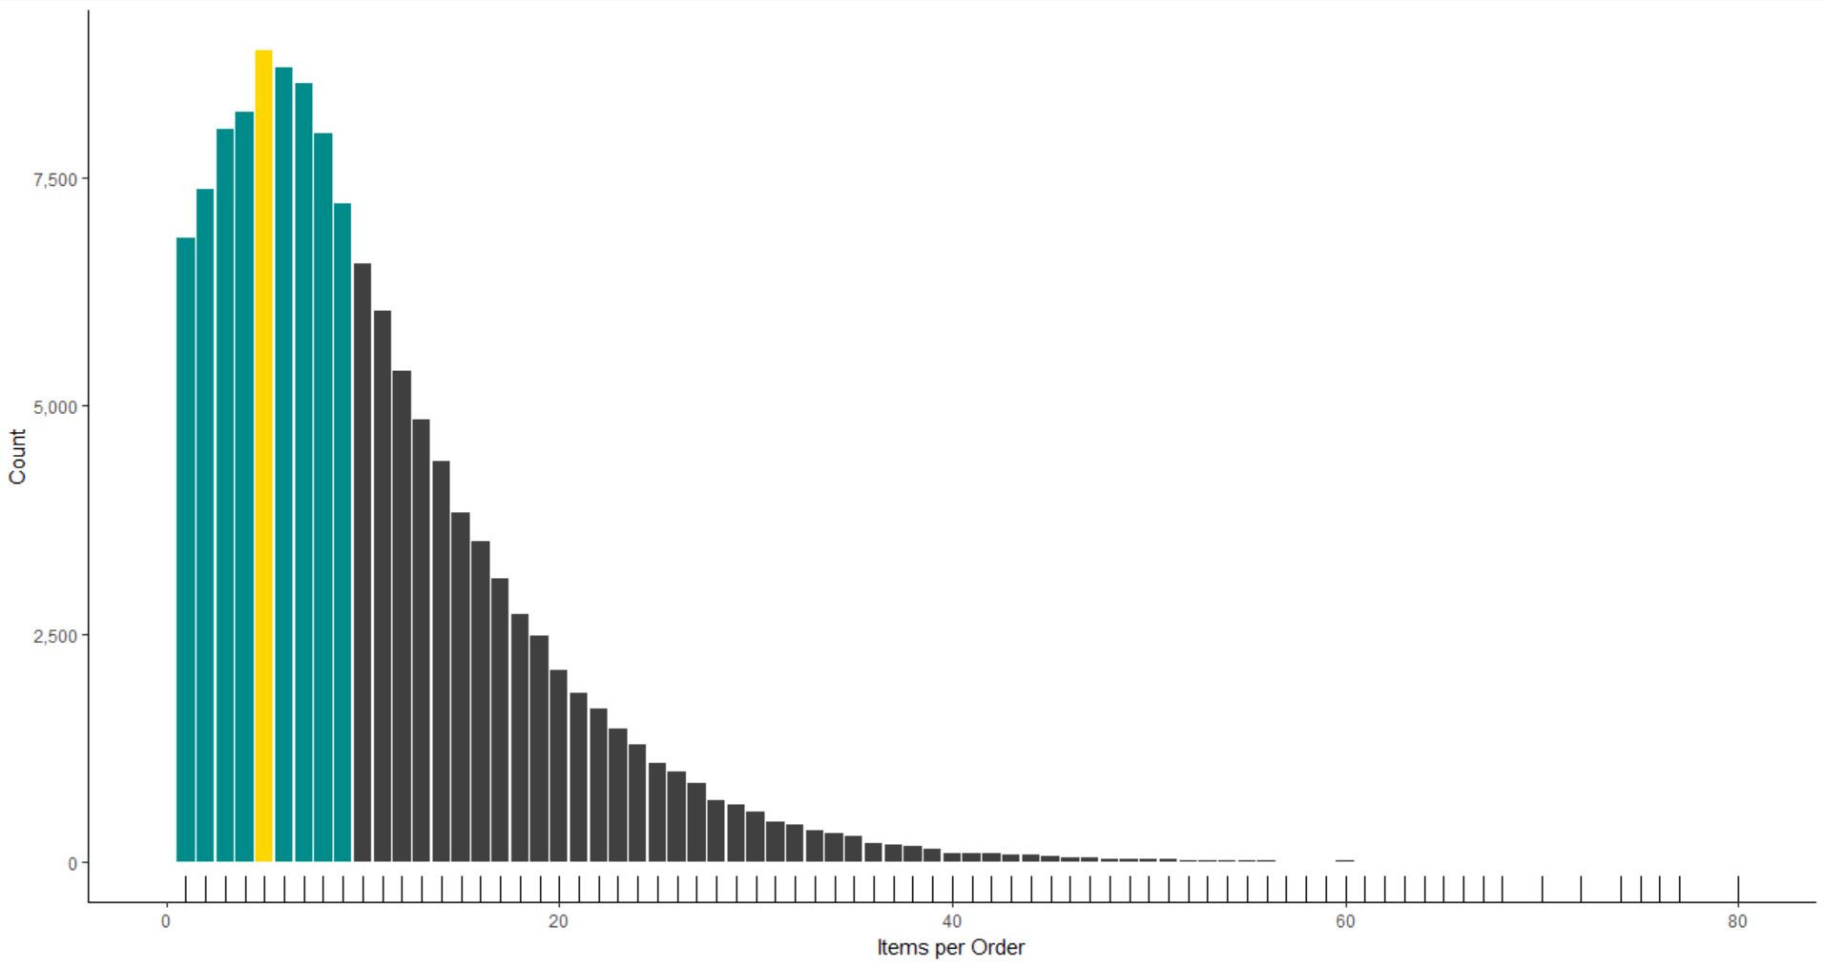
Output :

Majorly, number of items per Order is between 1-10 items, with 5 items per Order being the highest among all the orders.

Process :

To generate this visualization, we used the dataset order_products_train and we grouped the dataset according to the column named order_id using group_by command of R. Then we extracted the last values of add_to_cart_order column to get the highest number of items that each Order has, using the summarize command provided in dplyr library of R. And then we plotted the last values of add_to_cart_order column on the x-axis and it's count on the y-axis.

Code:

order_products_train %>%
group_by(order_id) %>%
summarize(n_items = last(add_to_cart_order)) %>%
ggplot(aes(x = n_items)) +
geom_bar(fill = c(rep("cyan4",4),"gold",rep("cyan4",4),
rep("grey25",66)))+
geom_rug()+
coord_cartesian(xlim = c(0,80))+
scale_x_continuous(name = "Items per Order",labels = comma)+
scale_y_continuous(name = "Count", labels = comma)

5. How many Days between Current & Prior Orders?
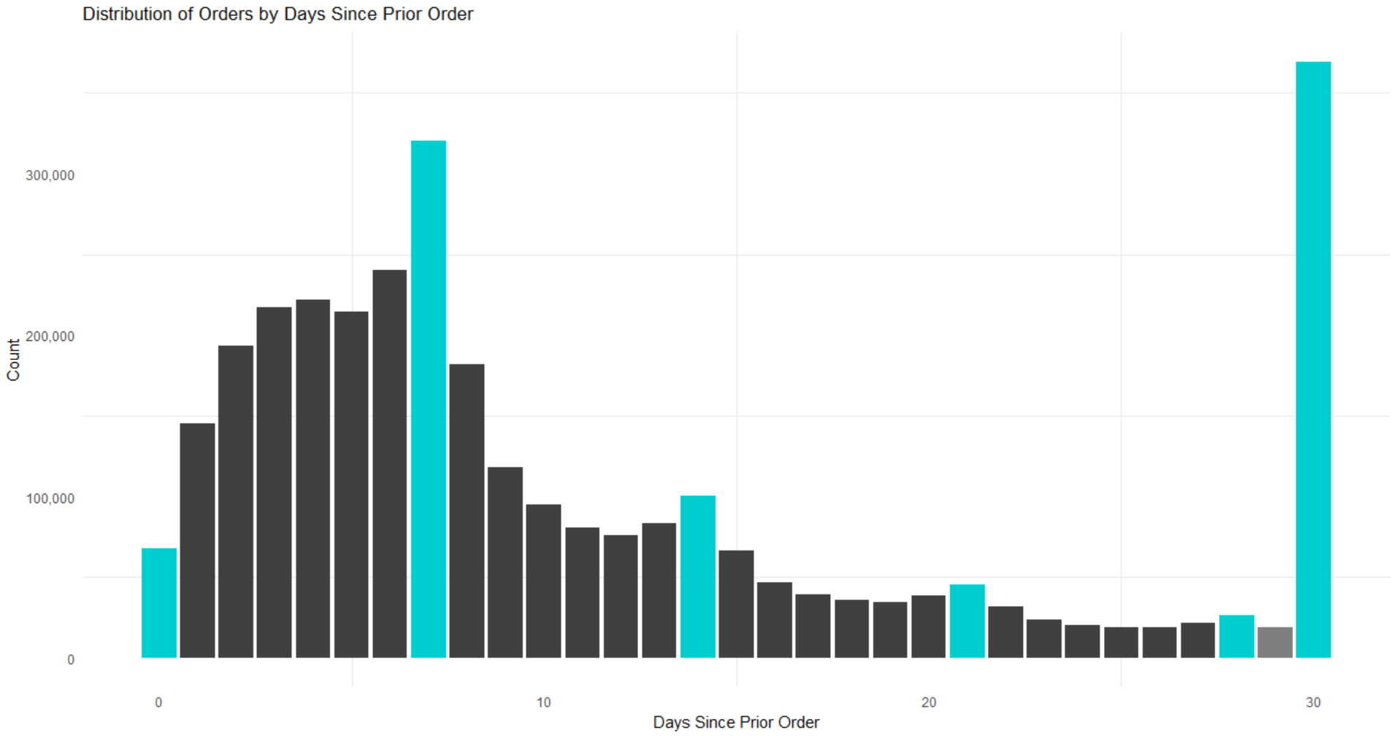
Output:

From the above graph, we see that around 50,000 consumers make orders on the same day since last order, around 300,000 consumers make orders on a weekly basis, and so on.
Process:

To generate this visualization, we used the dataset Orders and we took the column named days_since_prior_orders on the x-axis and generated a bar plot showing total Count on the y-axis with respect to the values in x-axis.

Code:

ggplot(orders, aes(x = days_since_prior_order)) +
geom_bar(fill = c("cyan3", rep("grey25", 6),
"cyan3", rep("grey25", 6),
"cyan3", rep("grey25", 6),
"cyan3", rep("grey25", 6),
"cyan3", "grey50", "cyan3")) +
theme_minimal() +
labs(x = "Days Since Prior Order",
y = "Count",
title = "Distribution of Orders by Days Since Prior Order") +scale_y_continuous(labels = comma)

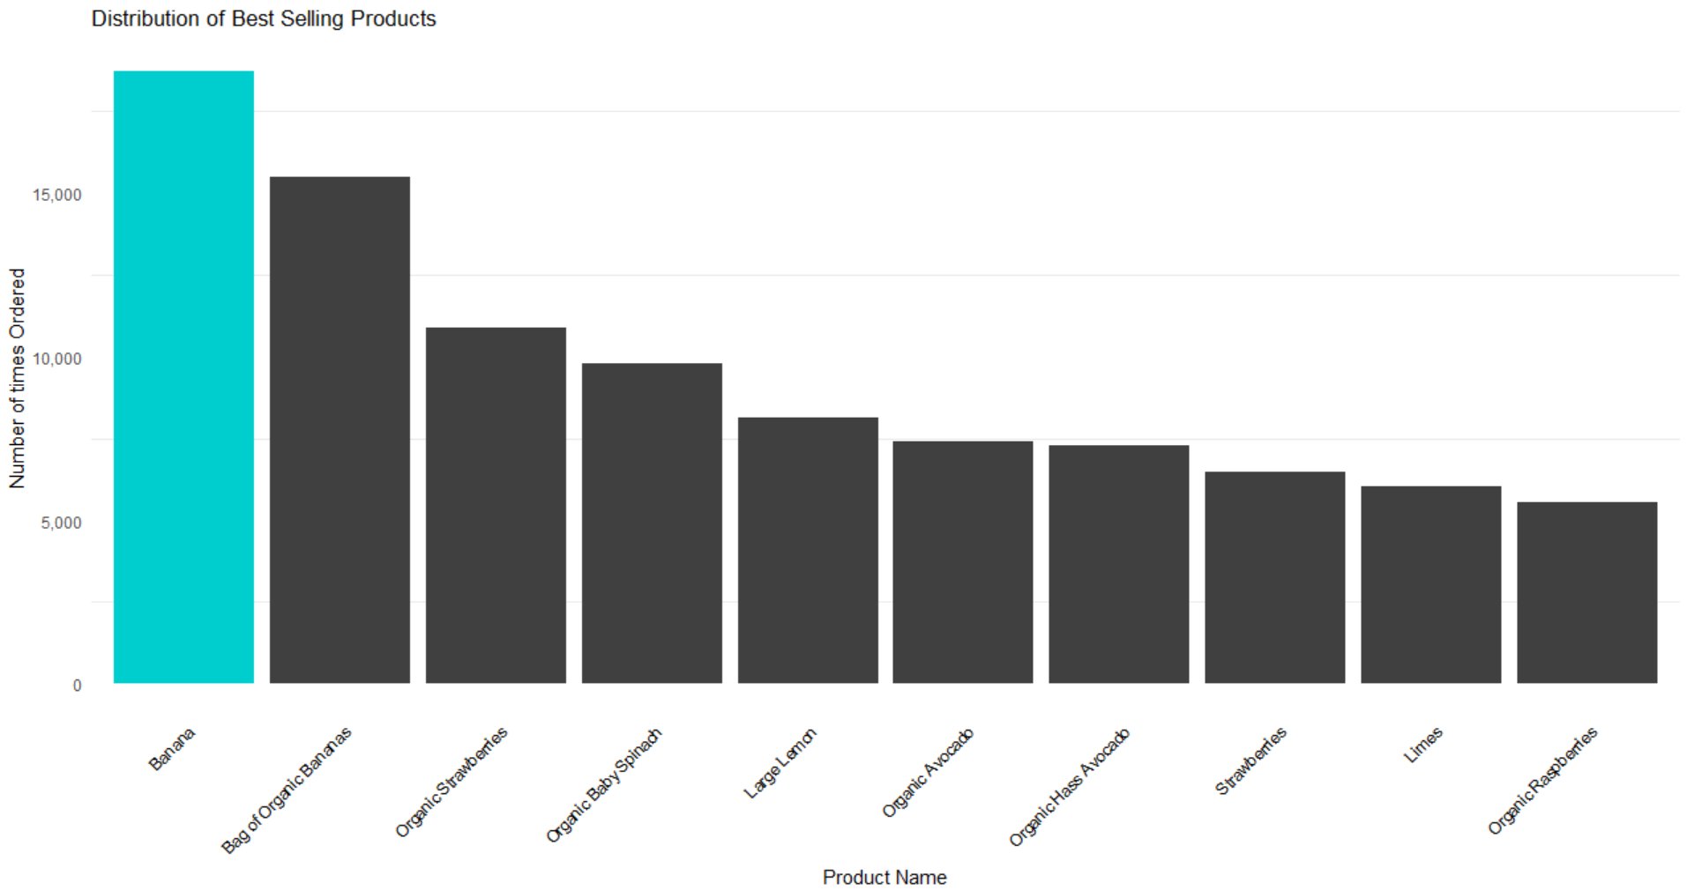
6. What are the best selling products?
Output :

Highest Selling product is Banana, which is bought by consumers 18,726 times. Other best selling products includes Bag of Organic Bananas, Organic Raspberries, etc.

Process :

To generate this visualization, we used the dataset order_products_train and we grouped the dataset according to the column named product_id using group_by command of R. Then we extracted the number of observations in the current group using the command n() (dplyr) and stored it's values in a variable called count, using the summarize command (dplyr). Then we select the top 10 number of oservations from the count variable using the top_n command (dplyr). Then, to know the best-selling product's names, we used the left_join command (dplyr) on the order_products_train by selecting the product_name from the products dataset. Then we arranged the count variable in descending order using the arrange & desc commands (dplyr). And then we plotted the reordered product_name column on the x-axis according to it's count and placing the total count of each such product on the y-axis.

Code:

order_products_train %>%
group_by(product_id) %>%
summarize(count = n()) %>%
top_n(10, wt = count) %>% left_join(select(products,product_id,product_name),by="product_id") %>%
arrange(desc(count)) %>%
ggplot(aes(x=reorder(product_name,-count), y=count)) + ...

7. What are the Top Selling Aisles?

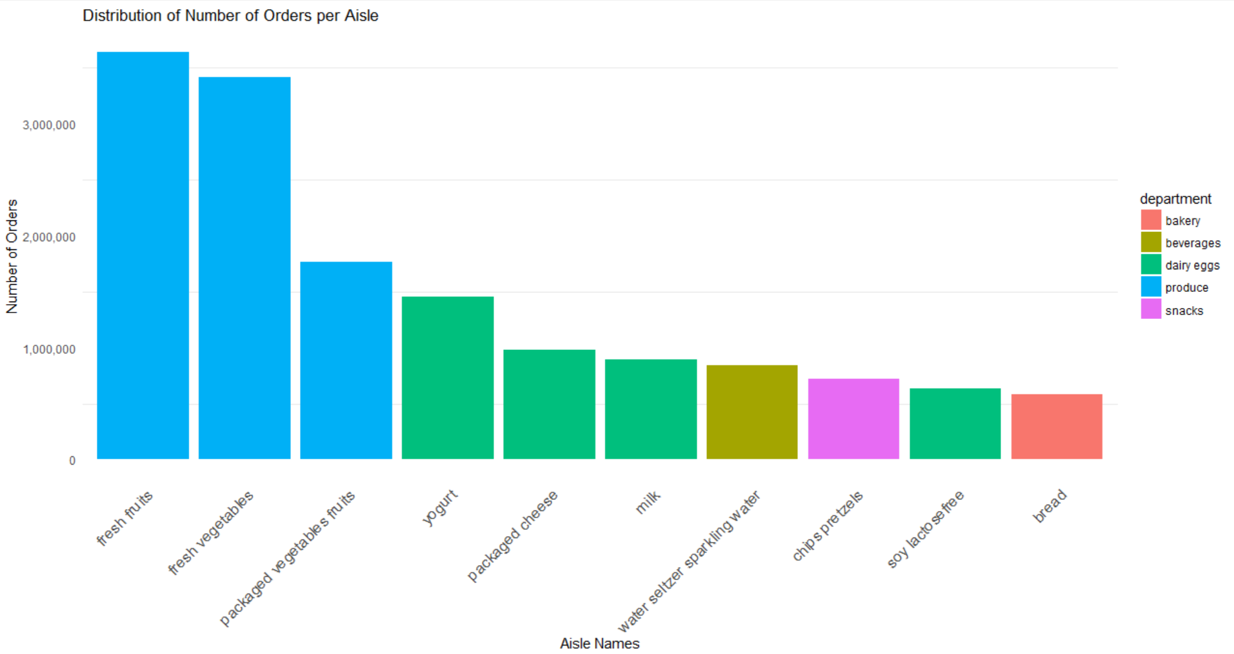
Output :

The top 10 aisles given above represent the 45.3% of the Total Sales. Out of the 10 top selling aisles, the aisles Fresh Fruits & Fresh Vegetables generated a maximum number of sales of more than 600,000 orders.

Process :

To generate this visualization, we used the dataset order_products_train and we attached the datasets products, aisles & departments into the existing dataset by using the command left_join (dplyr) over all 3 given datasets. Then we grouped the dataset order_products_train according to the aisle & department column.

We than use the command tally (dplyr) to get the number of observations in the current group, and then sort the output in descending order. Then we added a new column called perc to find out the percentage of individual aisle & department making the sell using the command mutate (dplyr).

Then we remove the grouping by ungroup command (dplyr) and we select the top 10 observations using the top_n command (dplyr). Then we extracted the number of observations in the current group using the command n() (dplyr) and stored it's values in a variable called count, using the summarize command (dplyr).

Then we select the top 10 number of oservations from the count variable using the top_n command (dplyr). And then we plotted the reordered aisle column on the x-axis according to it's count(n) and placing the total count (n) of each such aisle on the y-axis.

Code:

order_products_train %>%
left_join(products,by="product_id") %>%
left_join(aisles,by="aisle_id") %>%
left_join(departments,by="department_id")%>%
group_by(aisle,department)%>%
tally(sort=TRUE)%>%
mutate(perc = round(100*n/nrow(order_products_train),2))%>%
ungroup() %>%
top_n(10,n) %>%
ggplot(aes(x=reorder(aisle, -n), y=n, fill=department)) +
geom_bar(stat="identity") +
theme_minimal() +
theme(axis.ticks.x = element_blank(),
axis.ticks.y = element_blank(),
axis.text.x=element_text(angle=45, hjust=1, size = 12),
panel.grid.major = element_blank()) +
labs(x = "Aisle Names",
y = "Number of Orders",
title = "Distribution of Number of Orders per Aisle") +
scale_y_continuous(labels = comma)

8. How often People rebuy Items?
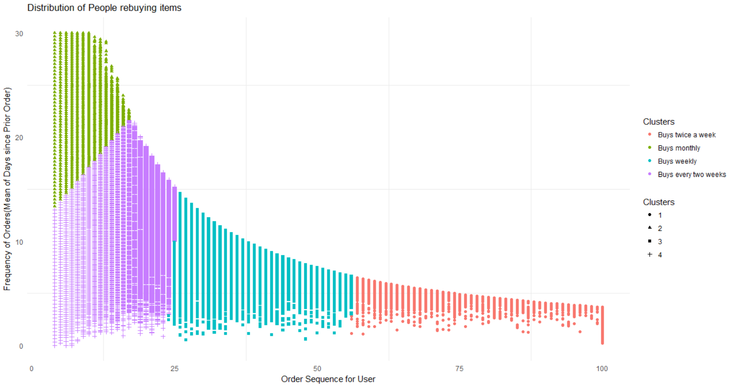

Output :

From the above visualization, we see 4 clusters of consumers. The ones who bought less than 25 items on Instacart, are having average freuqncy of buying monthly or buying every two weeks. The ones with total orders between 25 to 55, are having buying frequency of 7 days on average. And the ones with total orders more than 55, are having buying frequency of 4 days on average, i.e, they buy almost twice a week.

Process :

First of all, we group the data according to the users. We created a new dataset called user_freq from the dataset orders. We selected the columns user_id, order_number & days_since_prior_order from the dataset orders and after grouping them according to user_id using the group_by command (dplyr) we created two columns of user_freq, called total and frequency where total will store the maximum of order_number and frequency will store the mean of days_since_prior_order. So we can see that total will tell us the maximum number of orders done by each consumer and frequency will tell us the average days between each consumer's orders.
Once the dataset user_freq is created, we create a K-Means clustering of the dataset, using the columns total and frequency and we create a total of 4 clusters.

Then we plot the graph with total on the x-axis and frequency on the y-axis, and give them multiple colors according to the clusters created by Kmeans.

Code :

user_freq <- orders %>%
select(user_id, order_number, days_since_prior_order)%>%
group_by(user_id) %>%
summarise(total = max(order_number),
frequency = mean(days_since_prior_order, na.rm = TRUE))

set.seed(42)
clus <- kmeans(user_freq[,2:3], 4)
clus$cluster <- as.factor(clus$cluster)
Clusters <- clus$cluster
ggplot(user_freq,
aes(total, frequency, shape = Clusters, color = Clusters)) +
geom_point()+
labs(x = "Order Sequence for User",
y = "Frequency of Orders(Mean of Days since Prior Order)",
title = "Distribution of People rebuying items")+
scale_colour_discrete(name="Clusters",
labels = c("Buys twice a week",
"Buys monthly",
"Buys weekly",
"Buys every two weeks"))+
theme_minimal() +
theme(axis.ticks.x = element_blank(),
axis.ticks.y = element_blank(),
panel.grid.major = element_blank())

Part II : Market Basket Analysis
(also known as Affinity Analysis or Association Analysis)

Market Basket Analysis typically encompasses several modeling techniques based upon the simple principle that while shopping if you buy a certain group of items (also known as an itemset in machine learning lingo), you are likely to buy an other specific item or items along with that itemset. We analyze human shopping patterns and apply statistical techniques to generate frequent itemsets. These itemsets contain combination of items that people are most likely to buy together, based on past shopping history.

A simple example of an itemset would be people buying beer and diapers frequently
at the market. The itemset can be depicted as { beer, diapers }.

We can also build item association rules on top of these itemsets by analyzing shopping purchases. An example association rule can be denoted by using itemsets using the notation, { beer, diapers } -> { milk } which would indicate that if I am buying beer and diapers together, I am most likely to also purchase milk along with that!

Core Concepts & Definitions

- Transactional datasets indicate databases or datasets where the customer's shopping transactions are recorded daily/weekly and consist of various items bought together by the customers. In our case, we will use the Datasets provided by Instacart.

- Itemsets are defined as sets or groups of items which were bought together in any shopping transaction. Hence, these items are said to co-occur based on the transactions. We will denote itemsets as ISn where n denotes the n-th itemset number. The itemset values will will be enclosed in curly braces.

- Association Rules or just rules are statements which have a left-hand side (LHS) and a right-hand side (RHS), and indicate that if we have the items on the LHS for purchase, we are likely to be interested in purchasing the RHS items too. This signifies that the itemsets are associated with each other. They are denoted as ISx → ISy, which means that if I have itemset x in my shopping cart, I will also be interested in purchasing itemset y along with it. An example rule can be
{ beer } → { diapers }
which indicates that if I have beer in my cart, there is a chance I will buy diapers too!

- The frequency of an itemset is basically the number of times a particular itemset occurs in the list of all transactions. We can denote it as f(ISn), where ISn is a particular itemset and function f( ) gives us the frequency of that itemset in the whole transactional based dataset.

- The support of an itemset is defined as the fraction of transactions in our transactional dataset which consists of that particular itemset. Basically, it means the number of times that itemset was purchased divided by the total number of transactions in the dataset. It can be denoted as :
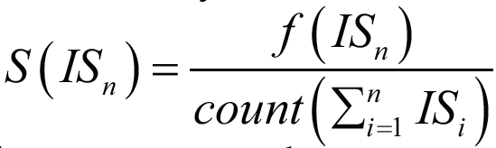

where S( ) denotes the support of the itemset Isn.
The support for an association rule is similar and can be depicted as :
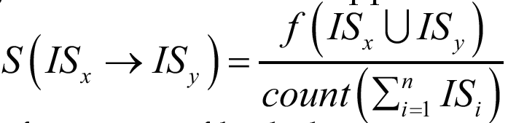

where we use the union operator to see the frequency of both the itemsets occurring together in the transactional dataset.

When evaluating results from association rules or frequent itemsets, the higher the support, the better it is. Support is more about measuring the quality of rules detecting what has already happened from the past transactions.

- The confidence of an association rule is defined as the probability or likelihood that, for a new transaction containing itemset in the LHS of the rule, the transaction also contains the itemset on the RHS of the rule. The confidence for a rule can be depicted as :
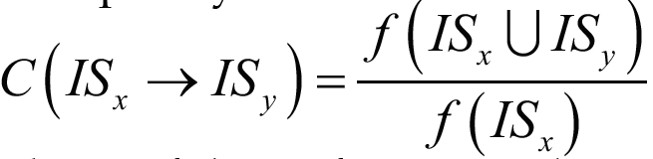

where C( ) denotes the confidence of the rule. Remember that confidence is more about detecting the quality of rules predicting what can happen in the future based on the past transactional data.

- The lift of an association rule is defined as the ratio of the support of the combination of two itemsets on the LHS and RHS together divided by the product of the support of each of the itemsets. The lift for a rule can be depicted as :
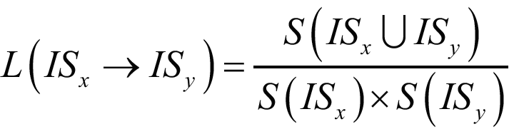

where L( ) denotes the lift of the rule.

The lift of a rule in general is another metric to evaluate the quality of the rule. If the lift is > 1 then it indicates that the presence of the itemset in the LHS is responsible for the increase in probability that the customer is also going to buy the itemset on the RHS. This is another very important way to determine itemset associations and which items influence people to buy other items, because if the lift has a value = 1, it means that the itemsets on the LHS and RHS are independent and buying one itemset will not affect the customer to buy the other itemset. If the lift is < 1, it indicates that if the customer has an itemset on the LHS then the probability of buying the itemset on the RHS is relatively low.

Our Implementation on R

For this kind of analysis, we are interested in the dataset called order_products_prior which contains orders prior to that users most recent order, and it consists of approximately 3.2 million orders.

But if we remember correctly, the dataset order_products_prior gives us information about following: order_id, product_id, add_to_cart_order and reordered, where each columns are self explanatory. But we need to know which products were bought in each order with their names for further analysis, and not just the product_id.

To do so, we give the following command :

order_baskets <- order_products_prior %>%
inner_join(products,by="product_id") %>%
group_by(order_id) %>%
summarise(basket=as.vector(list(product_name)))

What this basically does is, it creates multiple new columns in the dataset order_products_prior according to the dataset products and then it groups the whole dataset order_products_prior acording to the column called order_id. And finally, it creates a new column called baskets , which will contain all the product_name(s) and it removes all the columns except order_id.

Now, if we take a look at the dataset order_baskets :

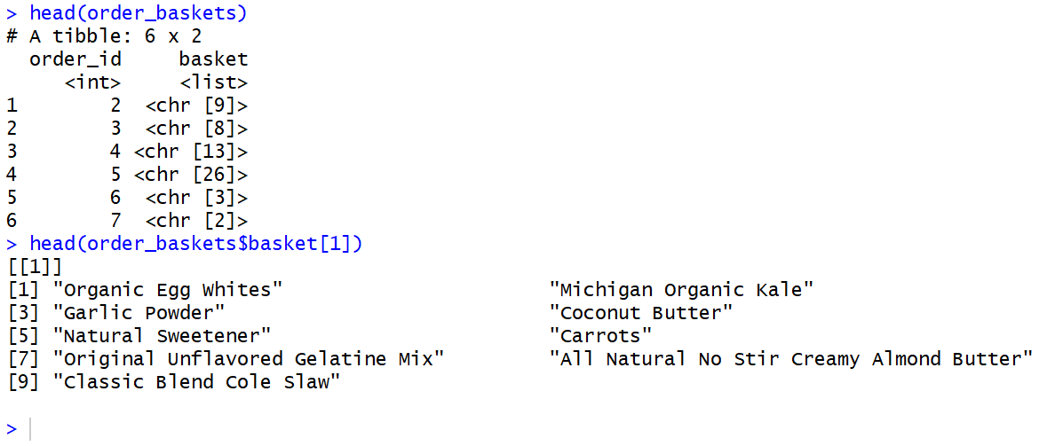
When executing the 2nd command in the picture above, we can see that the order_id 2 was having total 9 items in its cart, along with their names.

But the variable order_baskets is a data frame. We cannot do any kind of Assiciation analysis with such type of datasets. Our next step would be to convert the variable order_baskets into a transaction data type, where our aim would be fulfilled.

The command to do so would be :
orderTransactions <- as(order_baskets$basket,"transactions")
Now, let's take a look at the variable orderTransactions which is of type transactions, as expected. We will look at first two transactions of the dataset orderTransactions :

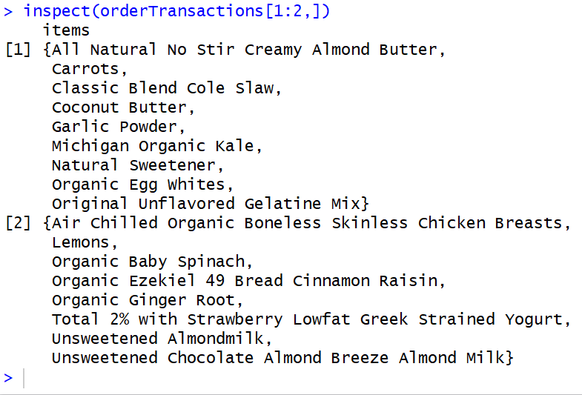

Now that we are ready with our Grocery transactions, we can find out more information about the data. One important step store all the basket sizes in a variable, which will be used later on.
The command to give is :
basketSizes<-size(orderTransactions)
And to get a summary of all the baskets (approximately 3.2 millions transactions) , we do :
summary(basketSizes)
We can see the distribution of basket sizes as follows :
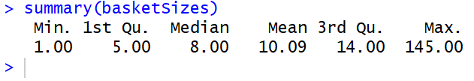

In some order, someone actually ordered a total of 145 items!

Generate Rules for Apriori

Now the interesting thing begins!

We will now generate rules using Apriori algorithm for the most frequent items in our transactional dataset orderTransactions. Using the library arules, we already have a built in function called apriori which will generate rules for us, for given support/confidence/lift and length of itemsets.

We have to keep in mind that our dataset is a very high dimensional, that is , there are a lot of transactions and each transactions has a lot of items in it. So, in high dimensional data, almost every event is rare! So when generating our rules, we have to keep our support quite low.

So for our first attempt, lets keep our support to be 0.01 , that is, 1 in every 100 transactions.
And then, lets generate the rules, using the apriori algorithm with the following command :

support<- 0.01
itemSets <- apriori(orderTransactions,
parameter = list(target="frequent itemsets",
supp=support,minlen=2),
control = list(verbose=FALSE))

Here, the variable itemSets will store all the output generated by the apriori command. Let's take a summary of the variable itemSets :
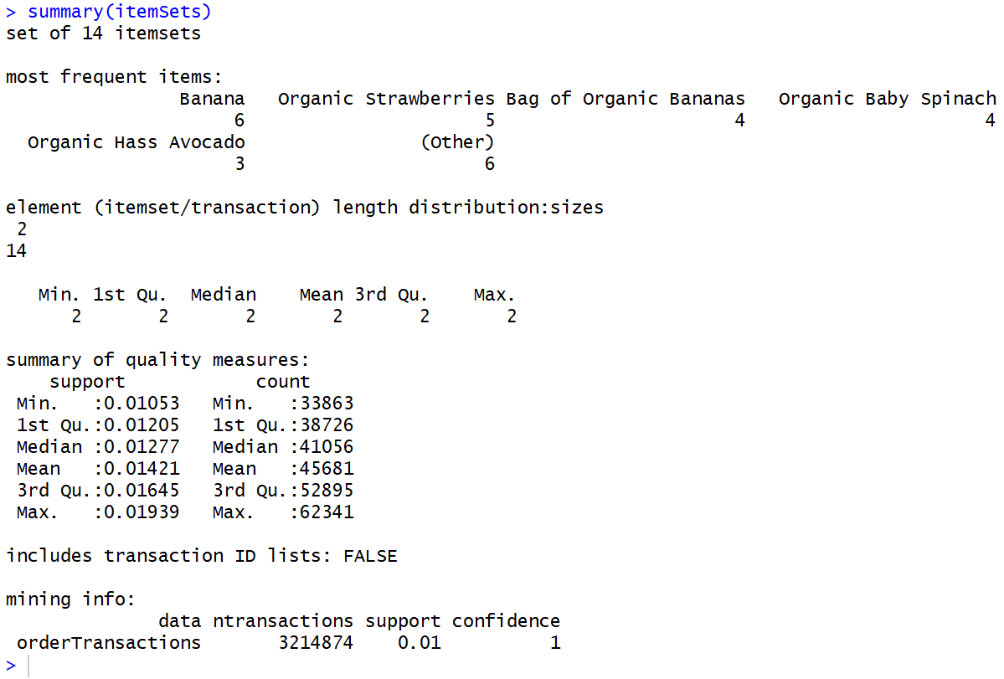
Now let's see what are the most frequent itemsets bought in a total of ~3.2 million transactions :
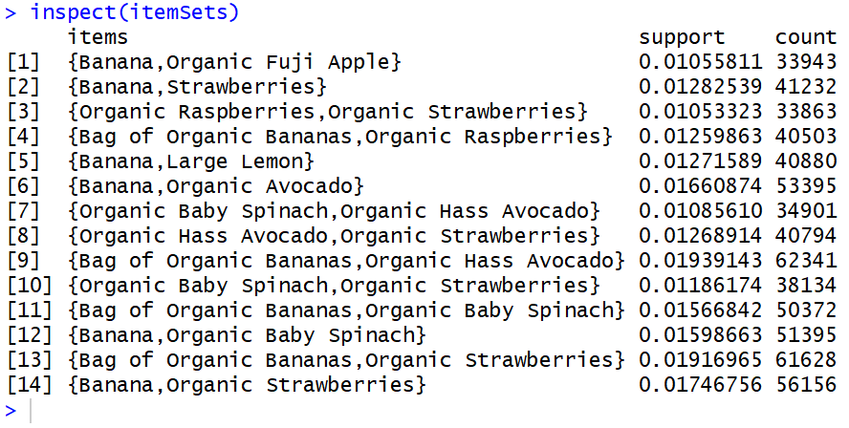

We can very clearly see that the itemset number 9 ie., { Bag of Organic Bananas, Organic Hass Avocado} is the winner out of all. It has been bought by consumers total 62,341 times , and thus it has the highest support values of 0.01939143!

Now, let's create a visualization of the most frequent itemsets :

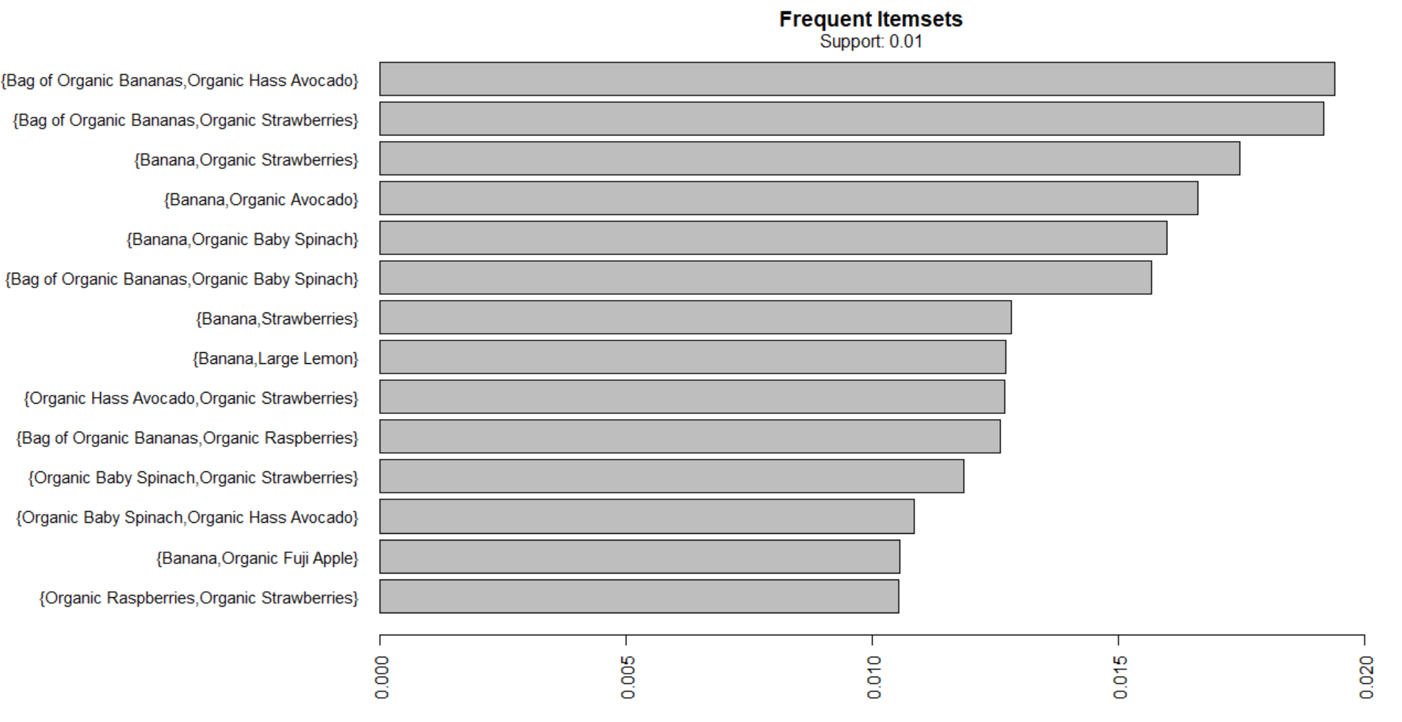
Now we can see things much more clearly because of the visualization. Here, x-axis represents the support of each itemsets.

In the above example, we tried to find out the frequent itemsets using the apriori algorithm. But now we will find out Association rules of multiple items on each other.

Generating New Association Rules

Lets say we want to find products that occur together in each basket, we can't make any direct use of people who haven't yet shown interest in multiple products. So we restrict the dataset to customers who have expressed interest in at least two products.

product_baskets <- orderTransactions[basketSizes > 1 ]

Let's try restricting the itemsets that we'll consider to those that are supported by at least 1500 baskets. This leads to a minimum support of: 0.0005 (1.5k divided by 3million) and let's take a minimum confidence of 0.01 , that is, rule is correct 1% of the time.

Now let's generate new rules with the following command :

rules <- apriori(product_baskets,
parameter = list(supp=0.0005,conf=0.01,minlen=2),
control = list(verbose = FALSE))

Let's see a summary of the newly generated rules :

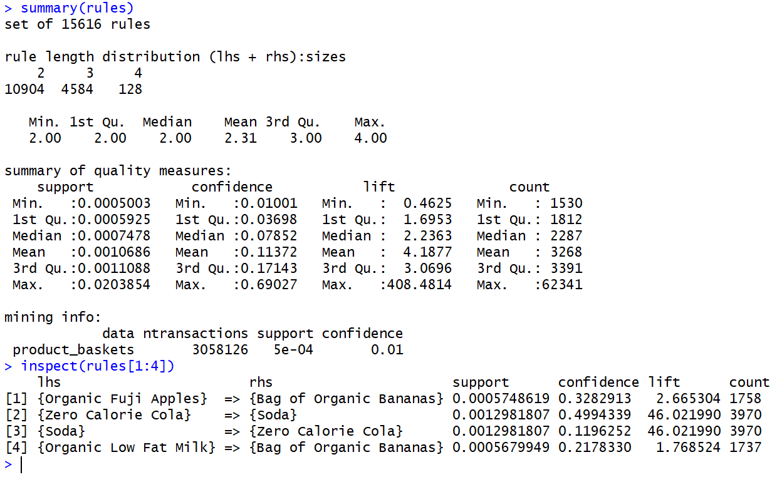
So we can see that the newly generated rules are a set of 15,616 rules in total, where 10904 rules are of length 2,4584 are of length 3 and 128 rules are of length 4. We can also see the range of variations of multiple parameters like support, confidence, lift and count. Using the inspect command, we see first 4 rules that is being generated.

Just to understand what these rules are trying to say, we take the example of rule number 1.
{Organic Fuji Apples} → {Bag of Organic Bananas} gives us a lift of ~2.66, telling us that if a consumer buys Organic Fuji Apples, then it is more than two times likely that the consumer will buy Bag of Organic Bananas along with it.

Now as there are a total of 15,616 rules, it is very likely that many of them are subsets of each other. So we need to find out the unique rules only. We will find out such rules using the following command :
nonRedundantRules <- rules[unique(as.vector(is.subset(rules, rules)))]

Once we remove redundant rules, we are left with only 7,808 rules which are truly unique.

Scatter Plot

Let's create a visualization of all the unique rules in a scatterplot where we keep support on the x-axis, confidence on the y-axis and lift according to the color indicated alongside.

We can very well see from the scatterplot below that maximum lift is having support less than 0.005 but having a high confidence at ~0.7. And the rule with maximum support has confidence ~0.3 and has very low lift also.
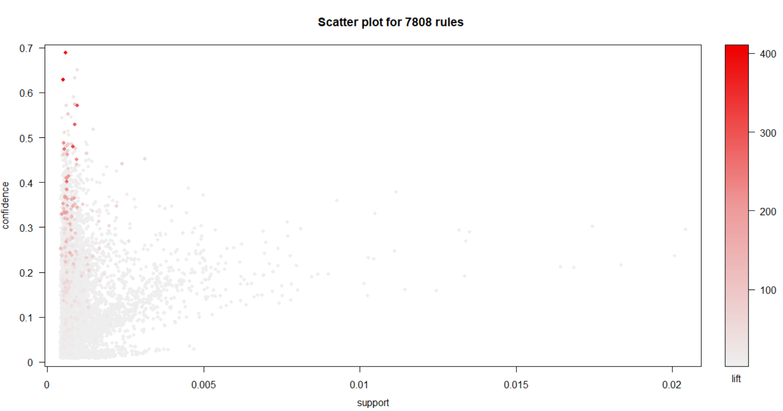
Matrix Shading Plot

Another type of visualization done on association rules is called Matrix Shading where on the x-axis, we keep the LHS Rules (also called Antecedent) and on the y-axis we keep the RHS Rules (also called Consequent). And we see the matrix graph with respect to two measures of lift and confidence.But this works best on smaller number of rules. So first of all we take a sample of 15 rules to perform matrix shading by the following command :
subrules <- sample(nonRedundantRules, 15)
Then we generate the matrix shading with the following command :

plot(subrules, method="matrix", shading=c("lift", "confidence"))

This is the following output :
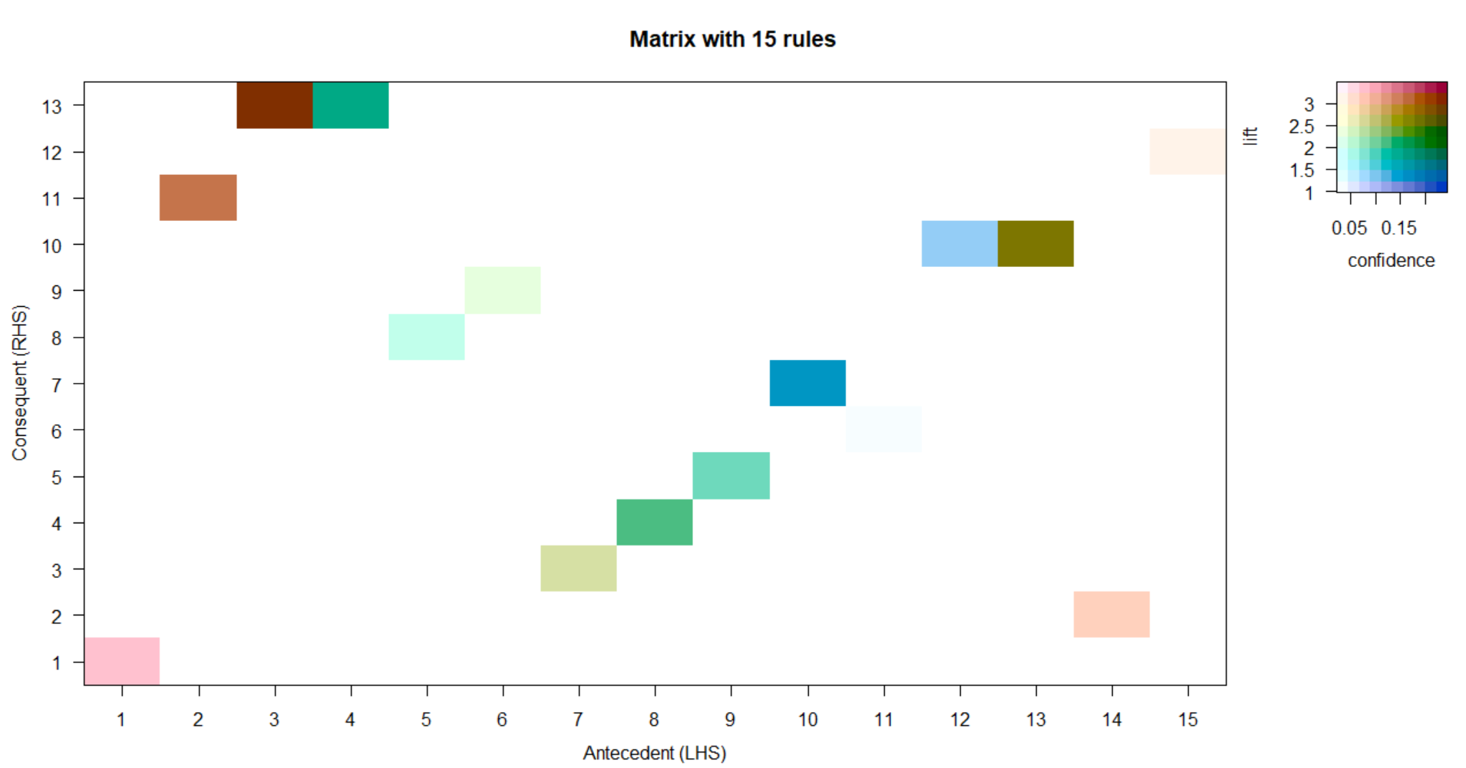

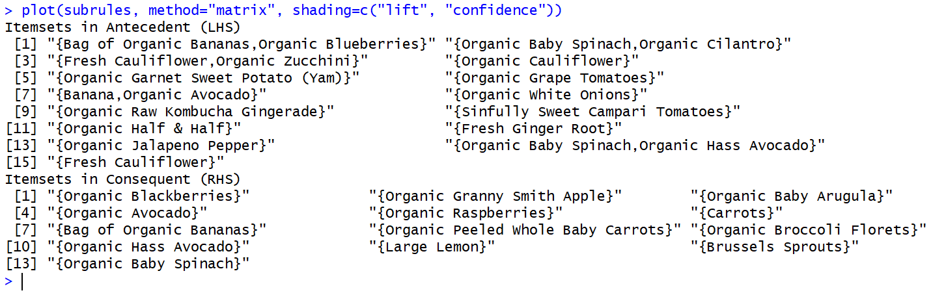
Here, we can predict that the LHS 3 and RHS 13 are having very high confidence and lift and thus indicating us that if a consumer buys LHS item 3 it is very likely that the consumer will buy RHS 13 also, where LHS 3 is {Fresh Cauliflower, Organic Zucchini} and RHS 13 is {Organic Baby Spinach}. Similarly LHS 2 and RHS 11 are also highly co-related where LHS 2 is {Organic Baby Spinach, Organic Cilantro} and RHS 11 is {Large Lemon}.

Note that in this case, we generated a Matrix Shading using parameters confidence and lift. But we can use different parameters also like support or count also.

Parallel Coordinates Plot

Another type of visualization that can be done on association rules is known as Parallel coordinates plot. In this type of plot, a small sample of rules are taken and parallel coordinates are drawn indicating the sequence of items bought by consumers and the likely RHS item, where the density of colour of the paracords give us the lift. To generate a paracord, we give the following command :
plot(subrules, method="paracoord")

It generates the following plot :

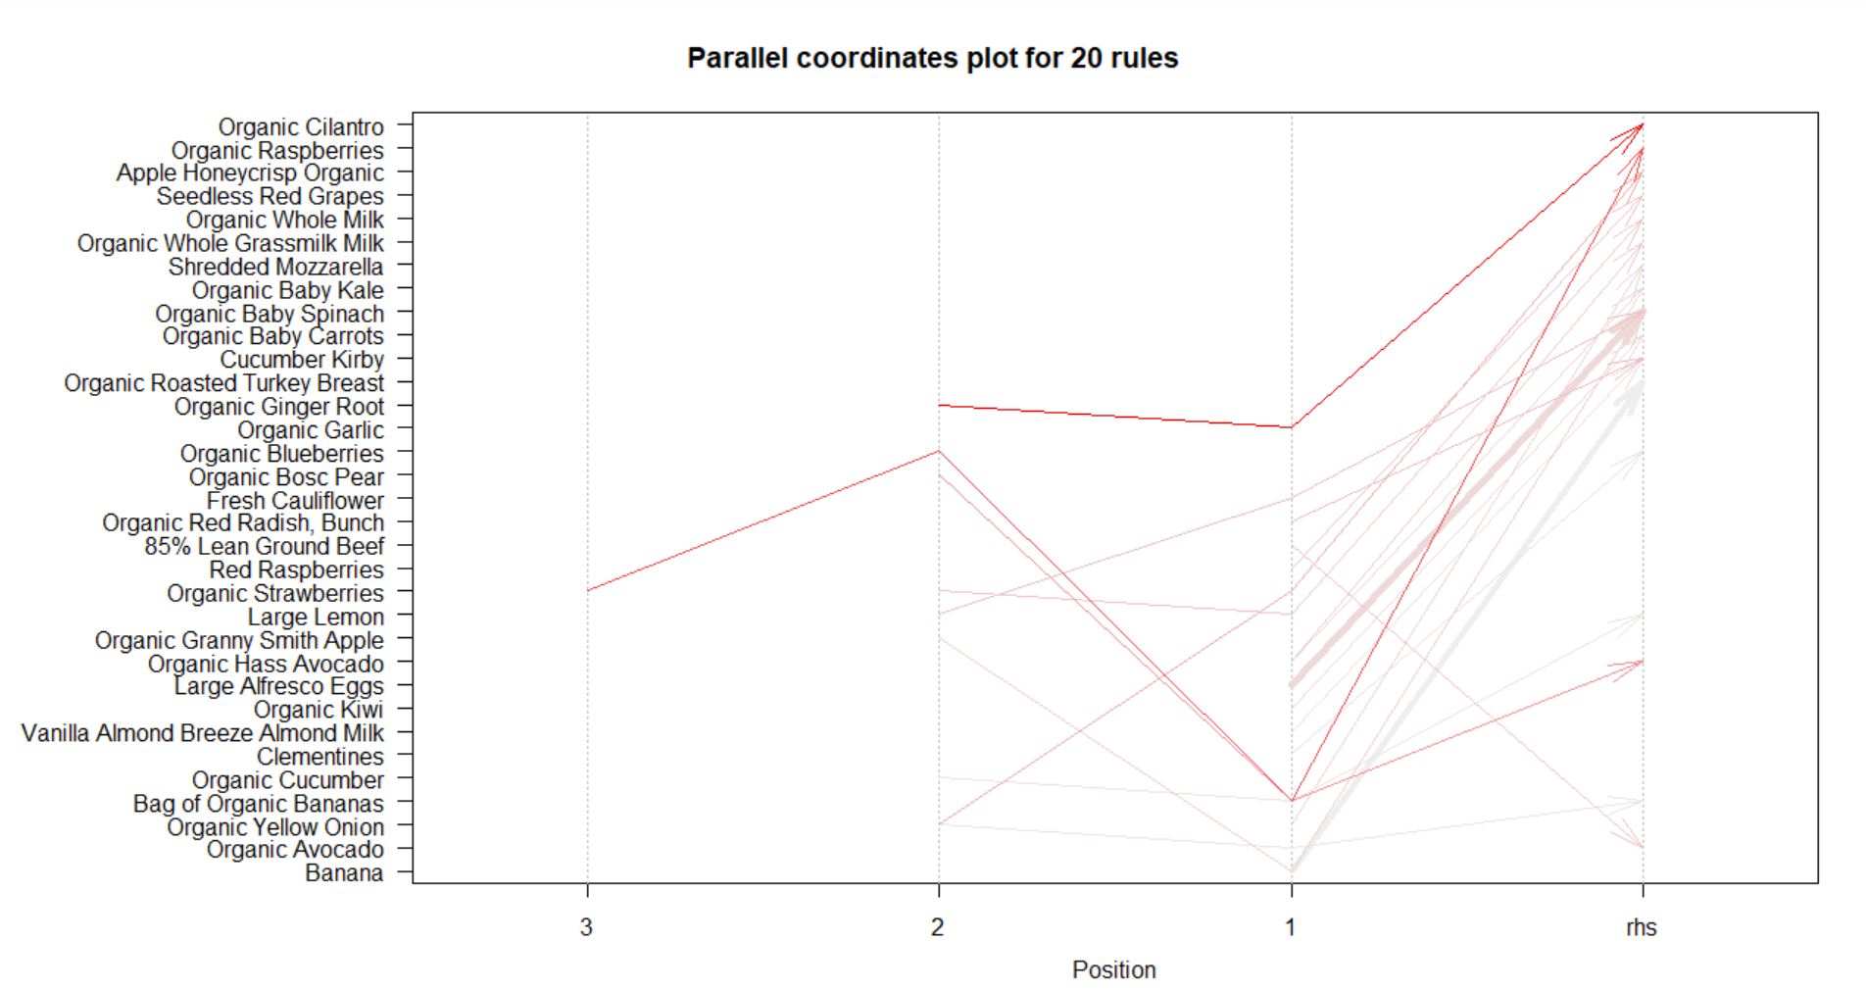
Here, we can very easily see that the rule {Organic Garlic, Organic Ginger Root} => {Organic Cilantro} are having the highest lift of 7.12 indicating that if a consumer buys {Organic Garlic, Organic Ginger Root} together, it is 7 times likely that the consumer will buy {Organic Cilantro} also.

Rules related to specific Items

